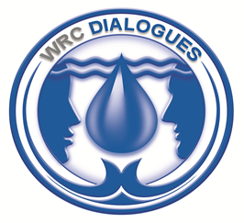


The Water Research Commission and University of KwaZulu-Natal

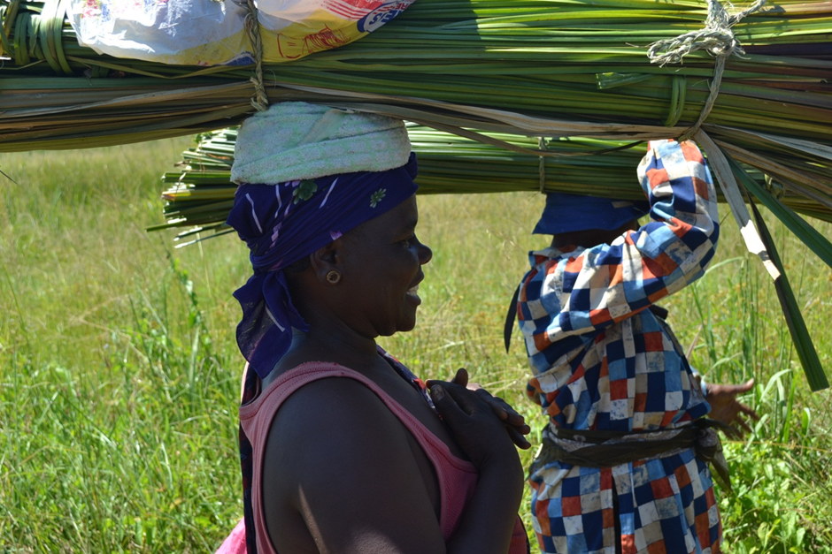

Invite you to the

A Dialogue: Khuluma Sizwe Series on

Wetlands and Wellbeing

Venue: Mbongolwane Wetland, near Eshowe, KwaZulu-Natal
Date and time: 12h00 on 22 May to 14h00 on 23 May 2013

The Khuluma Sizwe Series is an open lecture platform where speakers are invited to present on water resource issues affecting the South African public. These events are widely broadcasted and are open to the public.

Background and Rationale
We live in a rapidly changing world. What and how we think about our world, and how we act are also changing rapidly. Wetlands reflect this rapid change. Once perceived as hosting disease and pestilence they are now regarded as settings for human health. Regularly drained and ploughed up for agricultural purposes we now appreciate that the natural value usually exceeds their cultivated value. What has not changed is that wetlands, particularly for rural resource-marginalized residents, are invaluable sources of livelihood benefits – they are a means of survival. But, even here, patterns of use are changing rapidly. Rural communities previously saw wetlands as sources of communal benefit. Now, increasingly they are perceived as sources of private benefit. Madumbes previously cultivated for the home and immediate neighbours are now being traded to large supermarket chains.
The dialogue should assist in creating an environment where research can provide answers to how best to sustain wetland benefits and improve the value chain, including market for products. The demands on the ecosystem goods and services are changing and, with them, the complexity of managing for sustainability.
This dialogue has a threefold purpose:
- To improve our collective understanding of how people benefit from wetland-based ecosystem goods and services and how these benefits might be expanded/increased
- To understand how patterns of use are changing and what the drivers of these patterns of use are
- To establish how we might manage for sustainability, accounting for rapid change and increased needs/demand.
In this session of the WRC Khuluma Sizwe series we focus on the resource users. We are here to hear as directly as is practically possible of their experiences, their perceptions, their stories. In this way we hope to learn how the relationship between wetlands and people might be improved and ultimately the well-being of both society and the ecosystem are sustained.

Costs and logistics

Costs: No costs are involved. However, participants must make their own travel and accommodation arrangements. For advice on accommodation in Eshowe contact Duncan Hay on hay@ukzn.ac.za or 083 630 1749.RSVP: Please complete the registration form and send it to Mrs Zagry Scholtz at zagrys@wrc.org.za or fax to 012-331 2565 before 2 May 2013.

Provisional Programme
Programme Chair: Bonani Madikizela
Programme Facilitators: Thandazile Magubane and Duncan Hay

22 May 2013 | Field excursions
10h00 | Tour of Dlinza Forest and Aerial Boardwalk, Eshowe (Optional) | Duncan Hay
12h00 | Meet and briefing at Inina Craft Agency, Eshowe | Duncan Hay
12h30 | Lunch, Inina Craft Agency
13h30 – 17h30 | Tour of Mbongolwane wetland | Led by Dr Donovan Kotze
18h30 | Supper, Inina Craft Agency | Thandazile Magubane, Inina
23 May 2013 | Workshop at Mbongolwane
09h00 | Welcome | iNkosi Sithembiso Ntuli, KwaNtuli Tribal Authority
09h10 | Introduction and purpose | Mr Bonani Madikizela, WRC
09h20 | The Craigieburn Experience | Craigieburn farmers and Derick du Toit, AWARD
10h00 | The Mbongolwane Experience | Mbongolwane Residents and Thandazile Magubane, Inina
10h40 | Tea
11h10 | The Papenkuils Wetland Experience | Dr Donovan Kotze
11h40 | Plenary discussion
12h00 | Working session – how do we assess wetland contribution to well-being | Facilitated by Duncan Hay
13h00 | Closure and Lunch

